***Christie Aida & the Free Press Bio/EPK***

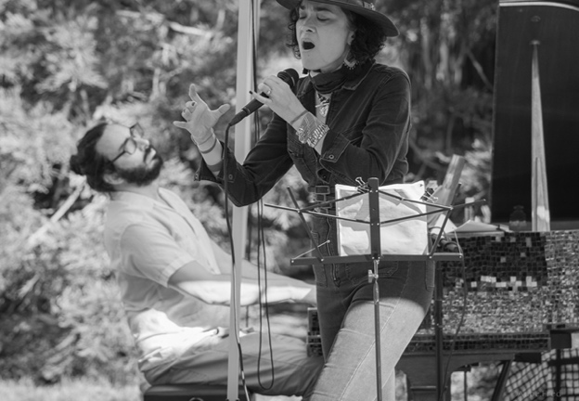

*“Christie Aida & the Free Press is a Filipina American-led San Francisco (District 5) based music collective with roots in soul, jazz, blues and improvisation. Vocalist/songwriter Christie Aida and her diverse group of artists conjure a deep and dynamic repertoire that constellates sounds from around the globe. Singing in Spanish, Tagalog, English and French, Aida deftly interweaves her wide-ranging influences to create a delightful and surprising mix of classics, deep cuts, and original numbers. Those originals often are informed by her sensitivity and advocacy for community organizing, social justice, and housing as a human right. As such, the stories, struggles, and everyday life experiences of Tenderloin and SOMA residents, in particular Filipinos and other communities of color, crop up in FPM’s music; for example, the narrative of the Tenderloin Museum’s physical home, the Cadillac Hotel, is the subject of a song “Reality House.” The song celebrates the residents and the history of the Cadillac, including one resident who practices harm reduction by using Narcan regularly to help others in crisis.”* The experiences of a formerly homeless Filipino friend are also the subject of the song, "Teody" where instrumentals converge around a percussive heartbeat driven by both batá and drums. Another original, "Near Avalon" is based on the countercultural influence of the former Avalon Ballroom on San Francisco. Jazz and Blues deep cuts include songs by NOLA soul superstar Irma Thomas. Other deep cuts include Filipina singers such as Pilita Corrales and Sugar Pie de Santo.

Free Press has played at the Golden Gate Bandshell, Bird and Beckett, various outdoor festivals, (including D6 Filipino festivals at 5M Park and Skybridge on Stevenson/All the Way Live Dance events), Flower Piano, Concerts at the Cadillac, Tenderloin Museum, Ivy Room, Library Laureates Celebration at the SF Main Library, and at many SF Branch libraries. In 2025, Christie Aida & the Free Press will play again at the Golden Gate Bandshell, SF Live Concerts, Music City, Medicine for Nightmares, Concerts at the Cadillac, SF Library branches and other outdoor festivals.

**Social Media/EPK/EPs:**

**Linktree:** [**https://linktr.ee/thefreepressmusic?utm_source=linktree_profile_share&ltsid=7577c153-f35d-4c45-bb46-9921123fd36b**](https://linktr.ee/thefreepressmusic?utm_source=linktree_profile_share&ltsid=7577c153-f35d-4c45-bb46-9921123fd36b)

**Instagram:** @thefreepressmusic

**Threads:** @thefreepressmusic

**TikTok:** the.free.press.music (These Tiktoks feature subjects of songs)

**Facebook:** @FreePressMusic

**Website: www.thefreepressmusic.com**

***2024 Free Press show reel:***

<https://www.youtube.com/watch?v=WAL6-4DrszA>

***EPs on Bandcamp:***

[*https://freepressmusic.bandcamp.com/album/house-of-welcome-ep-vol-1*](https://freepressmusic.bandcamp.com/album/house-of-welcome-ep-vol-1)